**College Planner Application**

**COSC 412**

**Fall 2020**

**Katherine Borowy**

**Preface**

The purpose of this project is to create a cross-platform product that allows college students to organize their class tasks and job opportunities and goals. This application will be able to import schedules for school and work as well as assignment due date and information. The app will also allow students to create goals and deadlines for job-hunting, and will provide job/internship suggestions based on the student’s major. I believe this is an important application, as many students admit that they are not organized. This application will organize all career essentials for a college student into one site.

**Table of Contents**

1. Introduction

1.1 Overview

1.2 Deliverables

1.3 Evolution of SPMP

1.4 References

1.5 Definitions and Acronyms

2. Project Organization

2.1 Process Model

2.2 Organizational Structure

2.3 Organizational Interface

2.4 Project Responsibilities

3. Managerial Process

3.1 Management Objectives and Priorities

3.2 Assumptions, Dependencies and Constraints

3.3 Risk Management

3.4 Monitoring and Controlling Mechanisms

4. Technical Process

4.1 Methods, Tools, and Techniques

4.2 Software Documentation

4.3 Project Support Functions

5. Work Elements, Schedule, Budget

5.1 Work Breakdown Structure

5.2 Schedule

5.3 Budget

Revision Sheet

10/27/20: revised cloud service information, specific schedule

Introduction

1.1 Overview

1.2 Deliverables

* Individual Project Meeting October ?

1.3 Evolution of SPMP

* SPMP will be updated throughout the semester when necessary

1.4 References

* TO BE ANNOUNCED

1.5 Definitions and Acronyms

* TO BE ANNOUNCED

Project Organization

2. Project Organization

2.1 Process Model: Waterfall Process

This model makes the most sense for a semester project

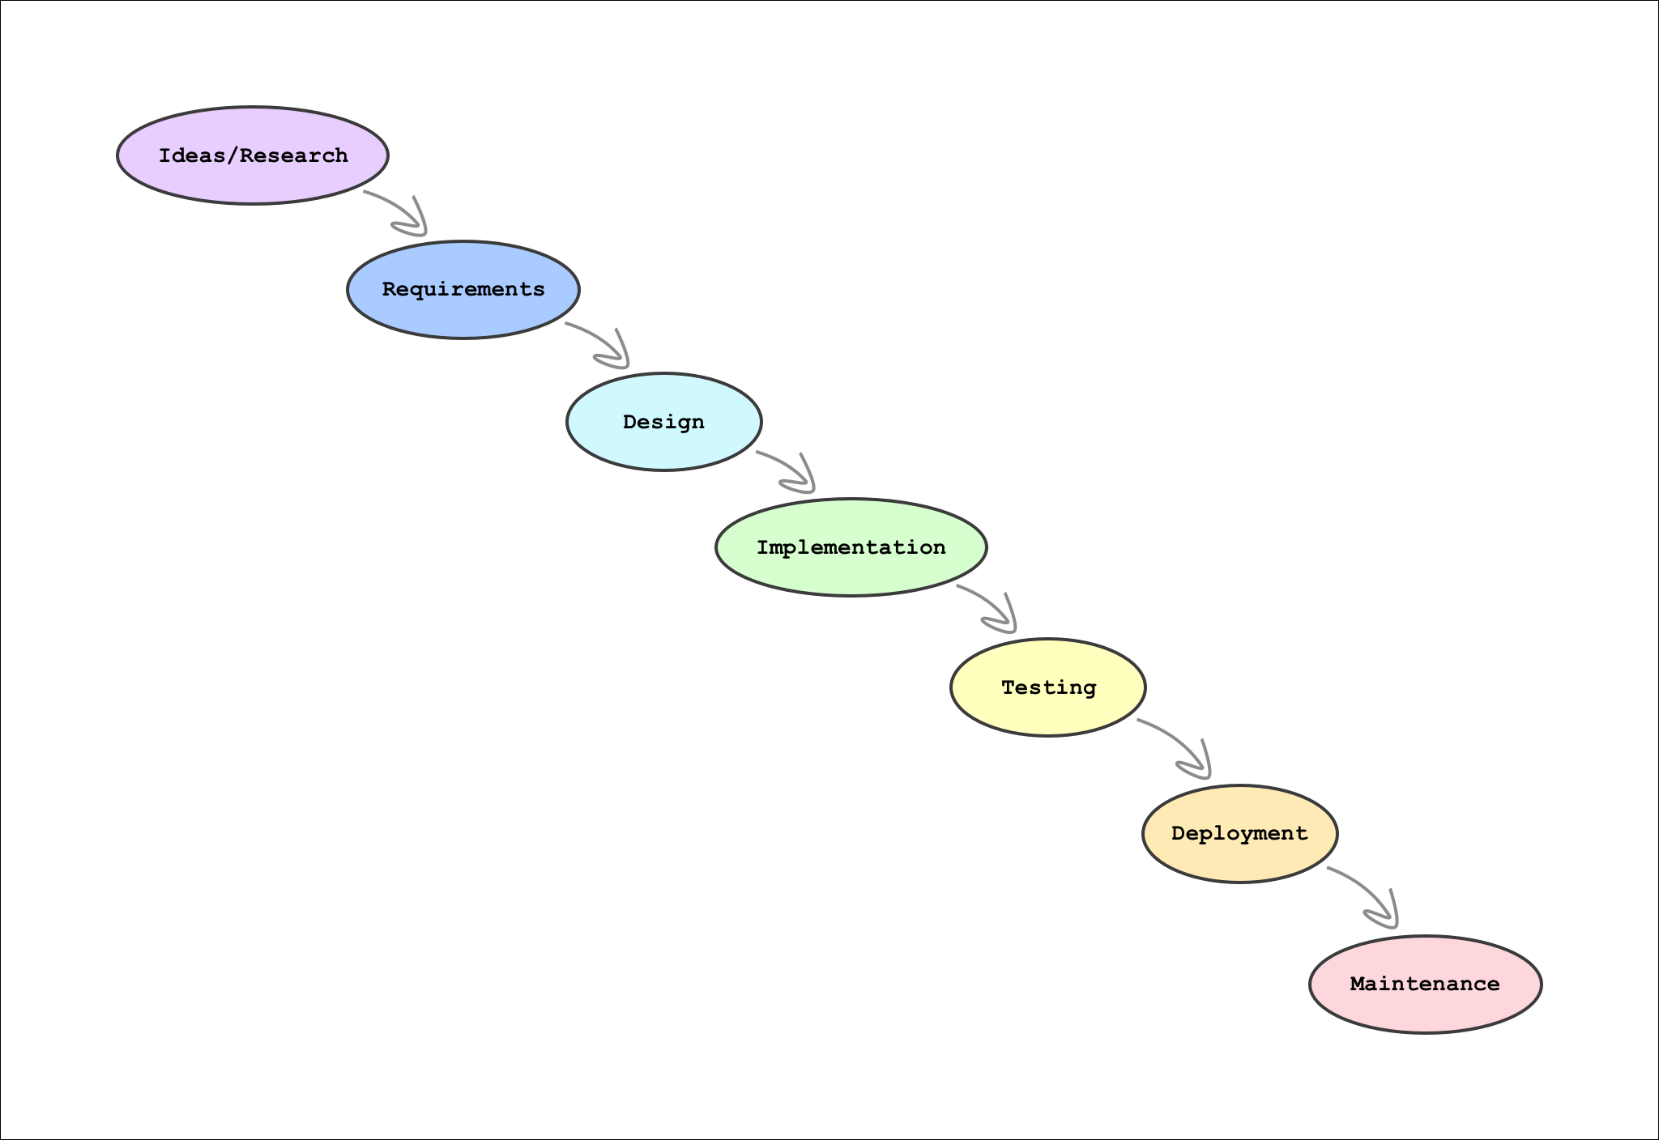

Managerial Process

3.1 Management Objectives and Priorities

* Since I am my own client, I will be able to work on my own time. I will have meetings with my professor should I have any questions or concerns.

3.2 Assumptions, Dependencies and Constraints

* Assumptions/Dependencies
  + As a student, I am hoping to use firebase for free or low cost, as I currently have no plans to move forward with the project after this semester. Firebase will be used as a host, cloud storage, and database for my website.
  + I will be seeking guidance from my professor, as well as receiving advice from family members.
* Constraints
  + Time: I have until the end of November to finish a working prototype.
  + Money: As I stated before, I will use firebase to host the website, because it is low-cost.
  + Outsourcing: I need to research code that is applicable to this project, relating to planning and scheduling applications. I am not planning on making my database, so I will need to outsource that as well.

3.3 Risk Management

* I will be using GitHub to save all my past iterations of the project incase of any accidents or issues.

3.4 Monitoring and Controlling Mechanisms

* The schedule I have created will keep me on track to complete the application to the best of my abilities.

Technical Process

4.1 Methods, Tools, and Techniques:

* Languages: HTML, CSS, Javascript, C#
* Text Editor: VScode
* Database: Firebase
* Web hosting: Firebase
* Repo: Github

4.2 Software Documentation

* Documentation will include:
  + This SPMP (basic info)
  + Requirements
  + Test Skeleton
  + All versions of software will be uploaded to github repository

4.3 Project Support Functions

* This project will be presented as a working prototype. While the majority of the website will run smoothly, there might be a few bug issues

Work Elements, Schedule, Budget

5.1 Work Breakdown Structure

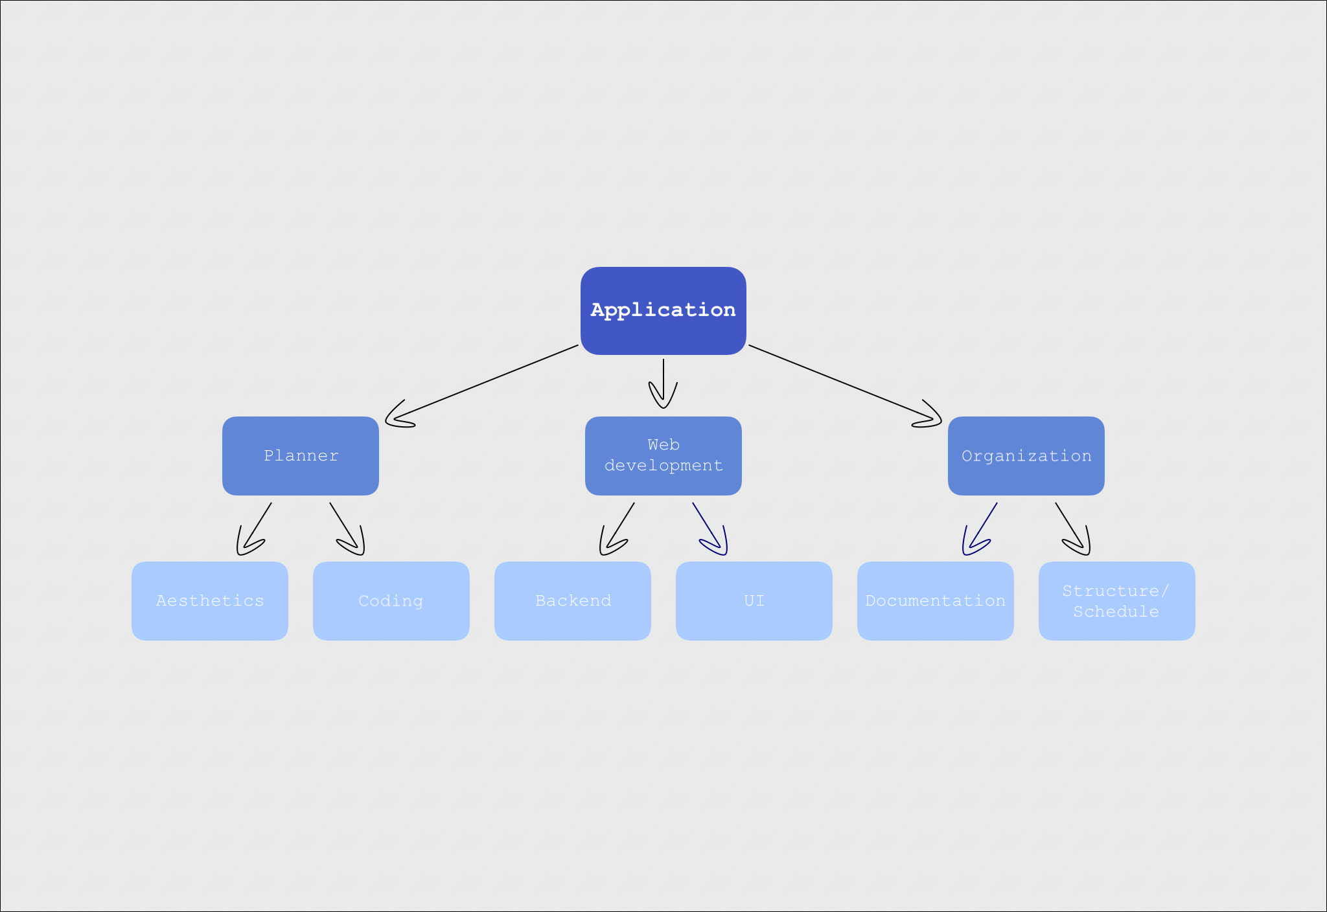

5.2 Schedule/Gantt Chart

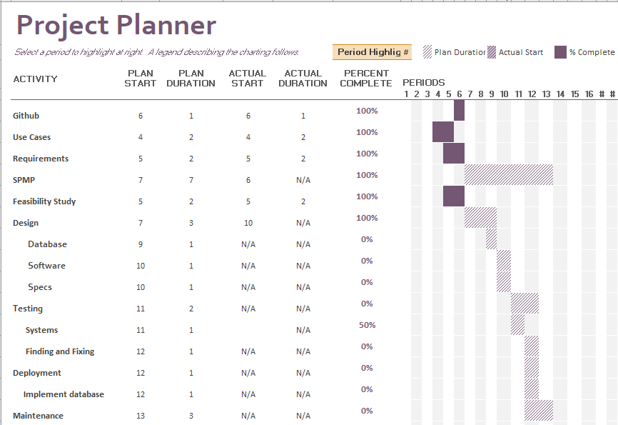

5.3 Budget

* Since I am a student, I would like to keep the cost of this project inexpensive. I am using developing tools that are free, and a relatively inexpensive hosting site.